How to enable a previously disabled a function or initiative
Login to the Edit mode of the USMAA website
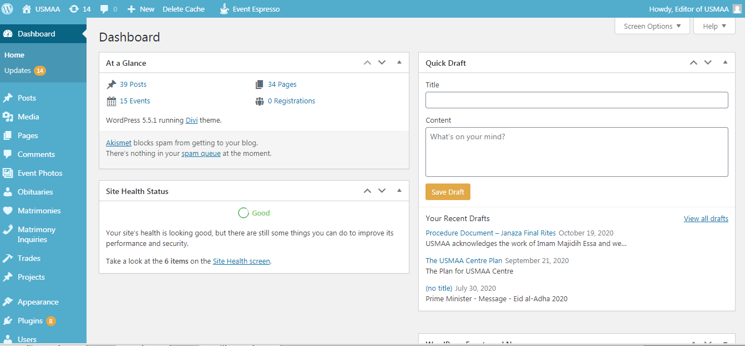

Click “Visit Site”
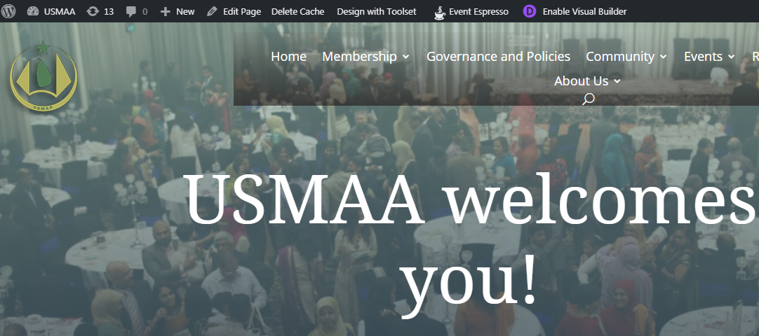
Then ‘Edit page’ the page from the top menu
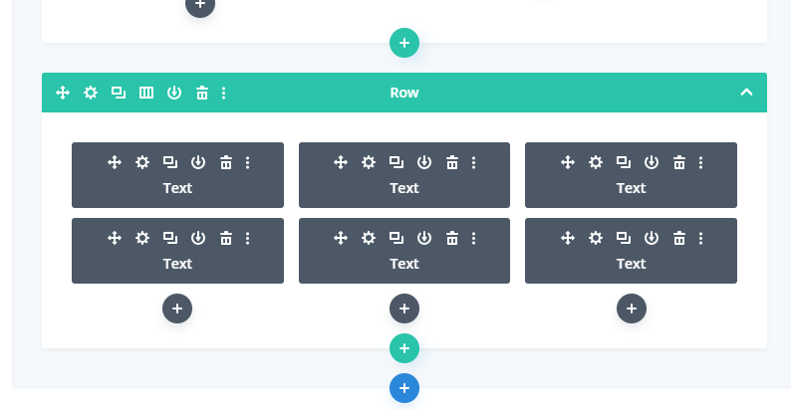
Scroll down, select the ‘cog’ from the above 6 boxes that you want to enable
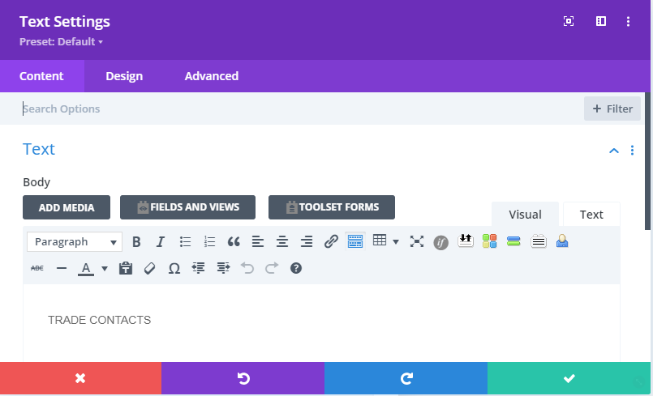

Next to the page name (e.g. Trade Contacts) delete commentary like “ - Not provided this year”.
Now scroll to the “Link” section below.
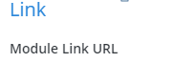
Expand it and add the link of Obituaries, Matrimony or Trades taken from the “dashboard page
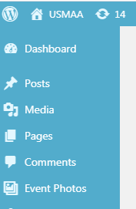

Click the below to save

Now click the update button
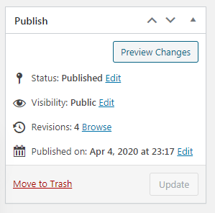
Log out of the page and test the WWW.USMAA.ORG.AU website for your desired outcome

