How to disable a function or initiative
Login to the Edit mode of the USMAA website
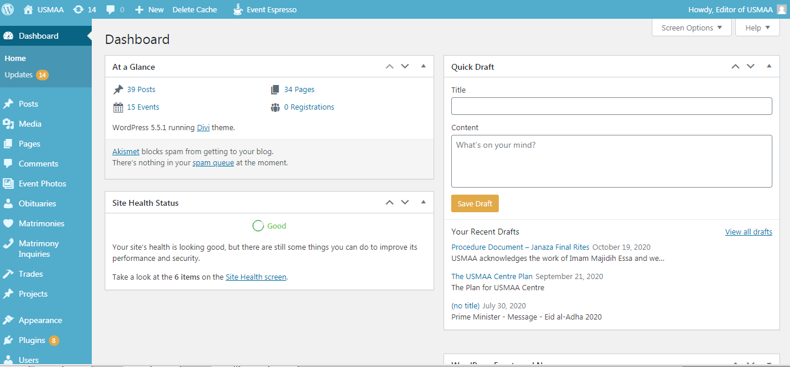

Click “Visit Site”
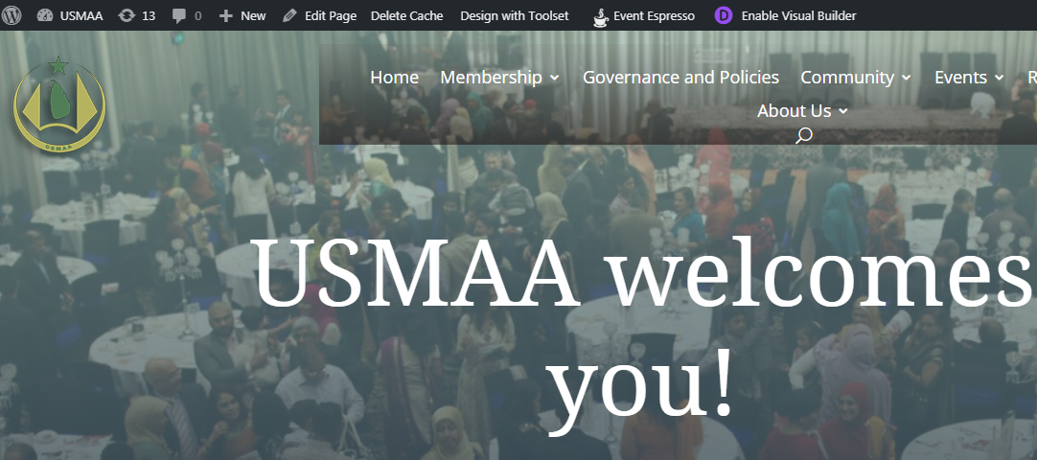
Then Edit page
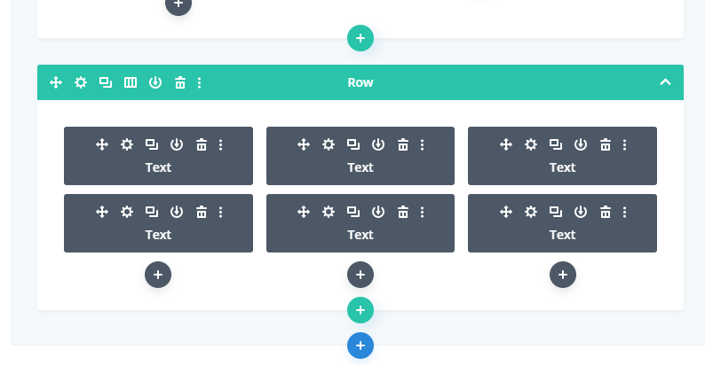
Scroll down, select the ‘cog’ from the above 6 boxes that you want to disable
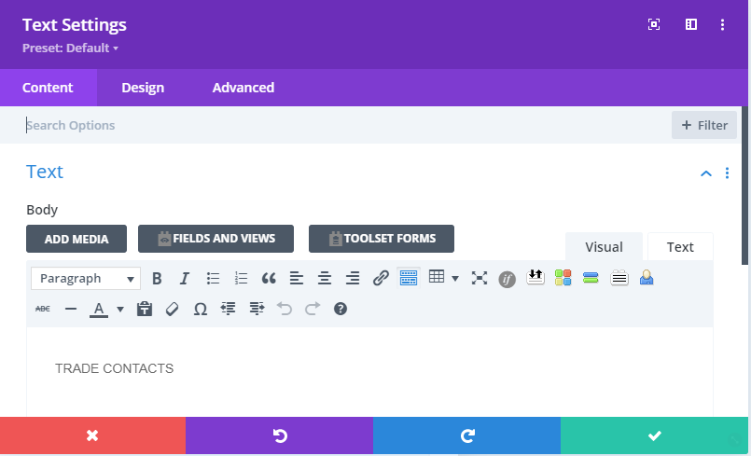

Next to the page name (e.g. Trade Contacts) place “ - Not provided this year”.
Now scroll to the “Link” section below.
Expand it and delete the link
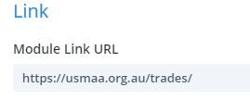
Click the below to save

Now click the update button
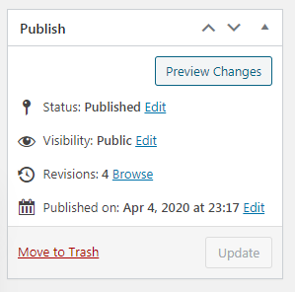
Log out of the page and test the WWW.USMAA.ORG.AU website for your desired outcome

